AMITY UNIVERSITY

UTTAR PRADESH


INTRODUCTION TO NETWORKING

LAB PRACTICAL FILE

DEPARTMENT OF COMPUTER SCIENCE AND ENGINEERING AMITY SCHOOL OF ENGINEERING AND TECHNOLOGY

SUBMITTED BY:

FACULTY NAME:

SHIVAM JAIN

DR. SHIPRA SARASWAT

(A2305219372)

5CSE6X

INDEX

Ex |  | Date of | Date of | Max. | Marks | Signatu-
p |  | allotment of | Date of | Max. | Marks | re of
p |  | allotment of | evaluation | Marks | obtained | re of
No. | Name of Experiment | exp. | evaluation | Marks | obtained | Faculty
 | Network Commands | 21/07/21 |  | 1
1 | on Linux / Unix | 21/07/21 | 10/11/21 | 1
2 | Understanding topologies | 28/08/21 | 10/11/21 | 1
 | To configure a switch
3 | appropriately with required | 04/08/21 | 10/11/21 | 1
 | properties
4 | To configure a | 11/08/21 | 10/11/21 | 1
4 | Router | 11/08/21 | 10/11/21 | 1
5 | VLAN Configuration | 18/08/21 | 10/11/21 | 1
6 | DHCP Configuration | 25/08/21 | 10/11/21 | 1
7 | Wireless | 22/09/21 | 10/11/21 | 1
7 | Configuration | 22/09/21 | 10/11/21 | 1
8 | RIP Configuration | 29/09/21 | 10/11/21 | 1
9 | IPv4 Configuration | 6/10/21 | 10/11/21 | 1
10 | IPv4 Subnetting | 13/10/21 | 10/11/21 | 1

Experiment 1

Aim: Basic Networking Commands

Ipconfig: (internet protocol configuration) is a console application of some operating systems that displays all current TCP/IP network configuration values and refresh Dynamic Host Configuration Protocol (DHCP) and Domain Name System (DNS) settings.
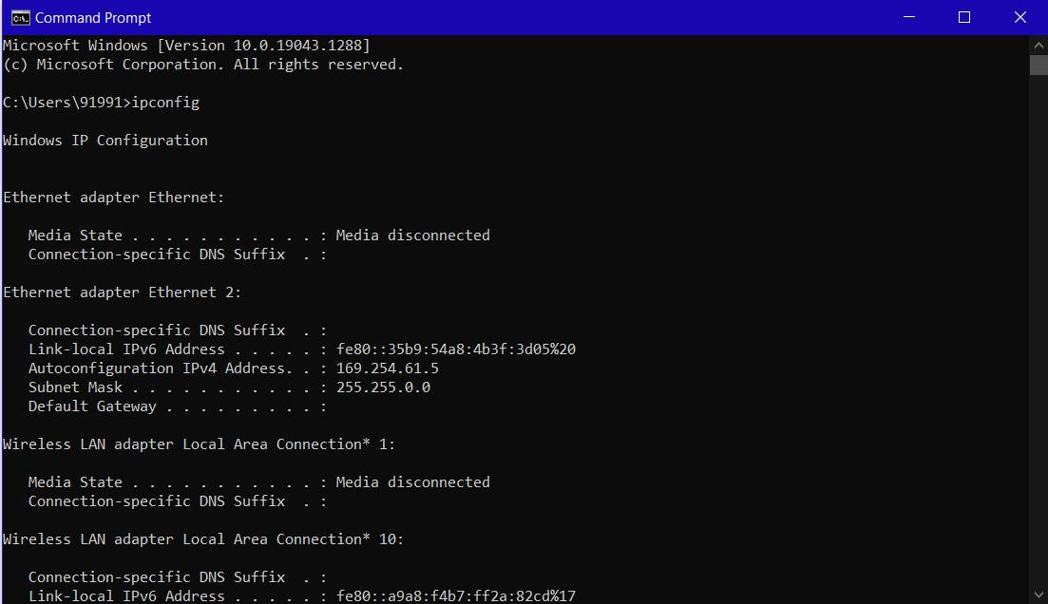

hostname: The hostname command is used to show or set a computer's host name and domain name.
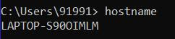

ping: A ping is a signal sent to a host that requests a response.

Option: -

-t: - ping the specified host until stopped.

-a: - resolve address to hostname.
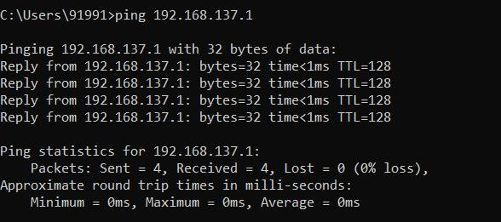

tracert: The tracert command is a Command Prompt command that's used to show several details about the path that a packet takes from the computer or device you're on to whatever destination you specify.
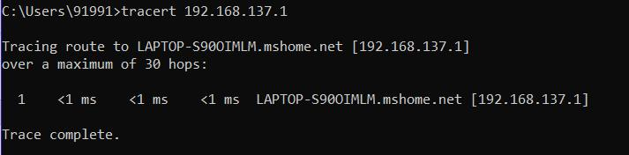

pathping: The PathPing command is a command-line network utility that combines the functionality of ping with that of tracert. It is used to locate spots that have network latency and network loss.
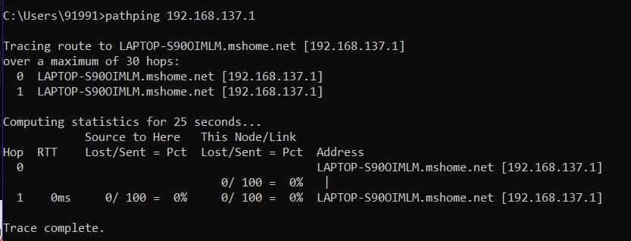

arp: ARP Command is a TCP/IP utility and Microsoft Windows command for viewing and modifying the local Address Resolution Protocol (ARP) cache, which contains recently resolved MAC addresses of Internet Protocol (IP) hosts on the network.

Options: -

-a: - Displays current ARP entries by interrogating the current protocol data.

-g: - Same as –a.
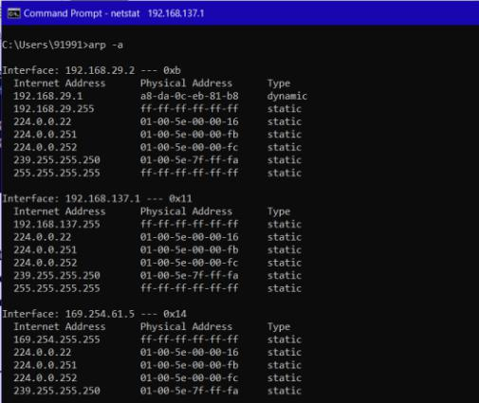

netstat: In computing, netstat (network statistics) is a command-line network utility that displays network connections for Transmission Control Protocol (both incoming and outgoing), routing tables, and a number of network interface and network protocol statistics.
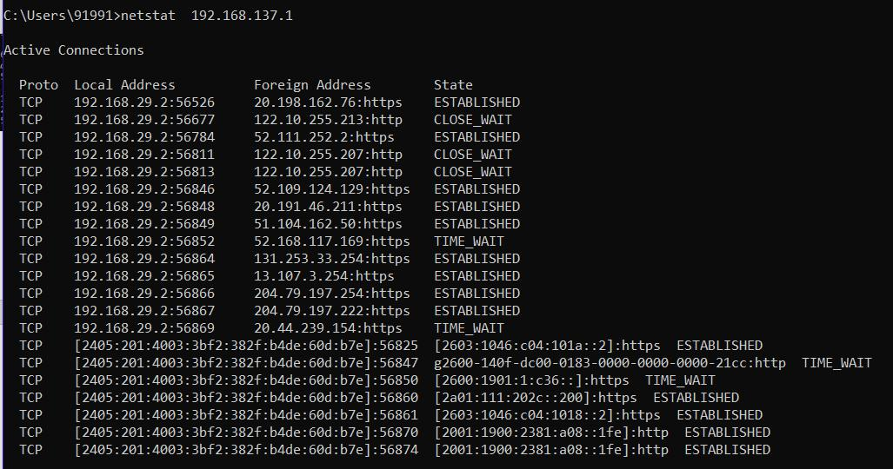
Experiment 2

Aim: To establish the various network topologies.

Tool used: Cisco Packet Tracer

Theory: Multiple computers can be connected in a network in several arrangements. These are called Network Topologies. These connections are made possible with the help of network devices called Hubs and Switches. The difference between a Hub and Switch is that a Hub is an unintelligent device, and it does not know where the intended recipient is located, therefore broadcasting any message it receives to all the connected terminals. However, switch, being an intelligent device, only sends the message to the intended recipient.

Output:
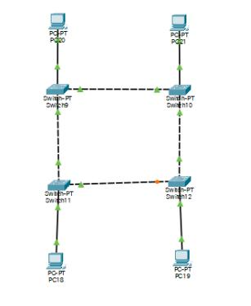
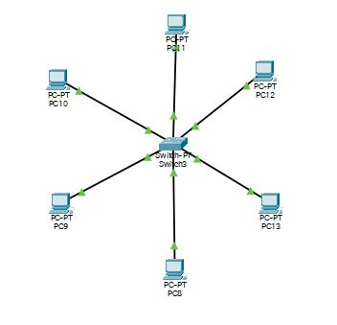

(Ring Topology) (Star Topology)
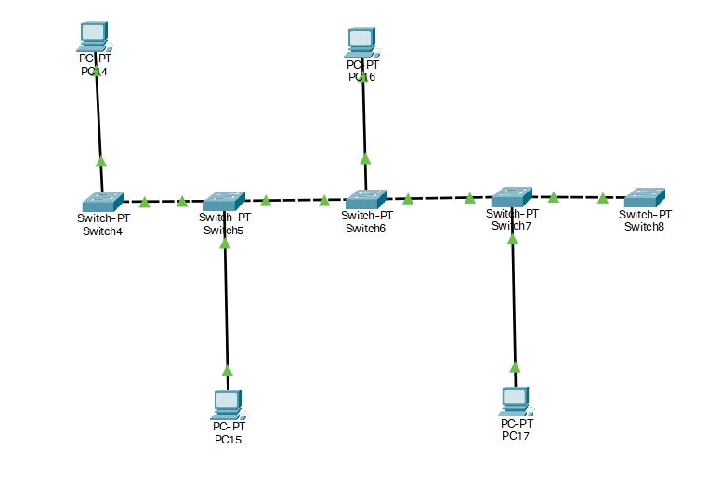

(Bus Topology)
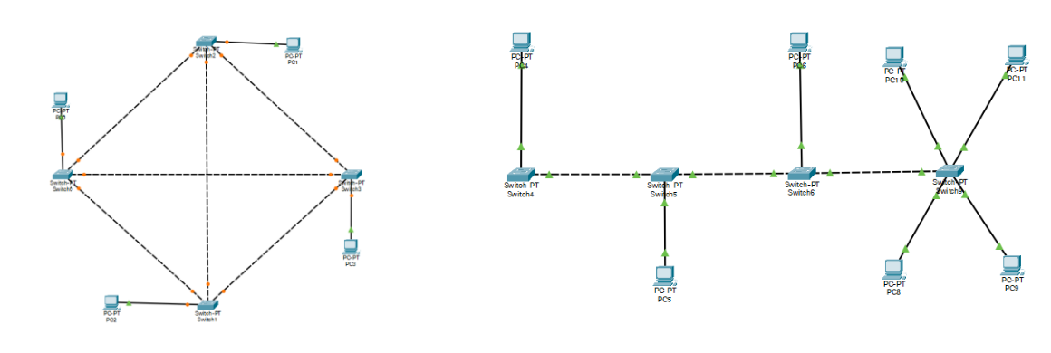

(Mesh Topology) (Hybrid Topology)
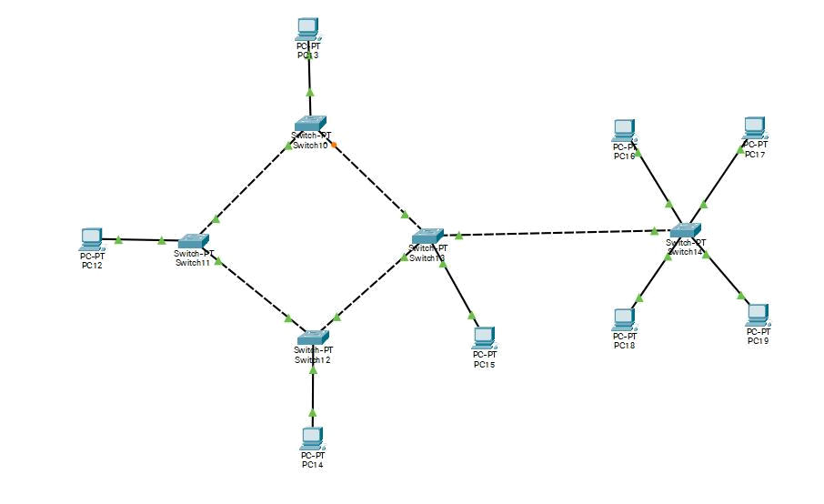

(Hybrid Topology)
Experiment 3

Aim: To configure a switch appropriately with required properties.

TOOL USED: Cisco Packet Tracer

THEORY: The properties of a switch can be configured using CLI, short for Command Line Interface. There are several modes in the CLI and each mode is used to modify certain specific attributes of the switch.

COMMANDS:

- enable To enter privileged EXEC mode, enter the enable command. Privileged EXEC from user EXEC mode, enter the enable command.

- conf t After you enter the conf t (configure terminal command), the system prompt changes from switch# to switch(config)#, indicating that the switch is in configuration mode.

- ip domain-lookup command: ip domain-lookup command is used to enable the Domain Name Server (DNS) lookup feature.

- interface: Used for switch interface configuration.

- shutdown: Used to shut down the switch.

- secret class: Used to enable a secret password for a specific privilege level.

- line con 0: This console port is mainly used for local system access using a console terminal.

- password: Configure Basic Password Settings Log in to the switch console.

- show running-config: Used to display the current running configuration.

- host: Used to configure the hostname for the switch

- ip address: Used to set the switch ip address and subnet mask.

- copy run-start: This command lets you save your running configuration to the router's startup configuration (NVRAM) so it will survive a reload.

- line vty 0 15: It is a range command, we are giving range of vty(virtual terminal line) from 0 to 15

- banner motd#: To configure a banner and message of the day (MOTD).

OUTPUT:
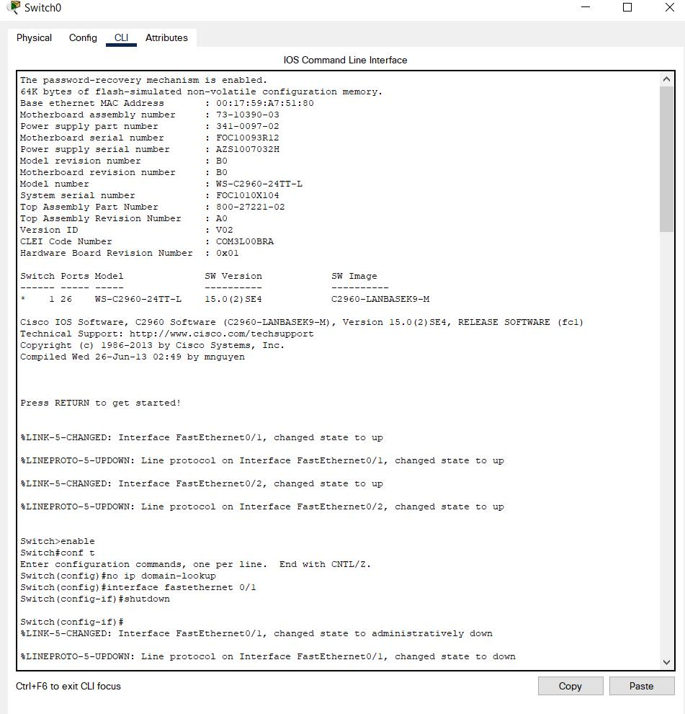
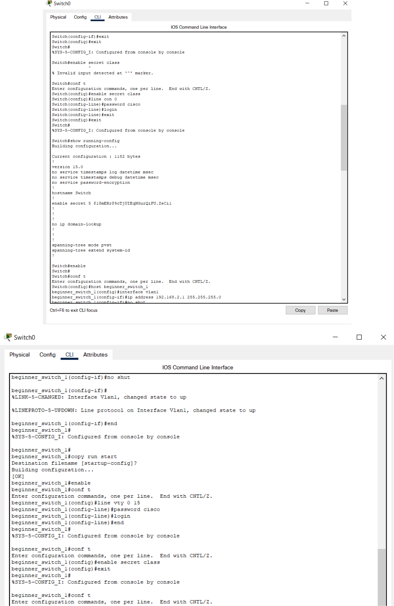
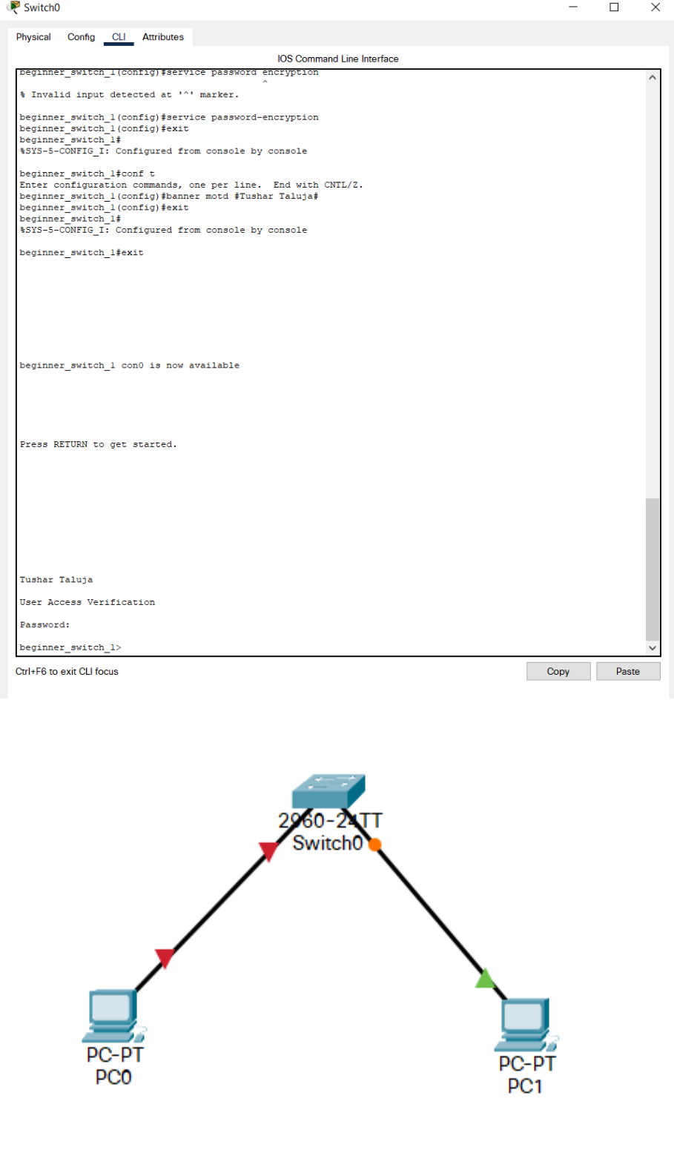

RESULT: The switch was successfully configured.
Experiment 4

Aim: Router configuration.

TOOL USED: Cisco Packet Tracer 7.3.1

THEORY: A router is a networking device that forwards data packets between computer networks. Routers perform the traffic directing functions on the Internet. Data sent through the internet, such as a web page or email, is in the form of data packets. A packet is typically forwarded from one router to another router through the networks that constitute an internetwork (e.g. the Internet) until it reaches its destination node.

A router is connected to two or more data lines from different IP networks. When a data packet comes in on one of the lines, the router reads the network address information in the packet header to determine the ultimate destination. Then, using information in its routing table or routing policy, it directs the packet to the next network on its journey.

The most familiar type of IP routers are home and small office routers that simply forward IP packets between the home computers and the Internet. More sophisticated routers, such as enterprise routers, connect large business or ISP networks up to the powerful core routers that forward data at high speed along the optical fiber lines of the Internet backbone.

Commands:

Router> enable

Router# conf t

Router(config)# host Router1

Router1(config)# interface g0/0/0

Router1(config-if)# ip address 192.168.1.100 255.255.255.0

Router1(config-if)# no shut

Router1(config-if)# interface g0/0/1

Router1(config-if)# ip address 192.168.2.100 255.255.255.0

Router1(config-if)# no shut

Router1(config-if)# interface loopback 0

Router1(config-if)# ip address 100.0.0.1 255.255.255.0

Router1(config-if)# interface loopback 1

Router1(config-if)# ip address 200.0.0.1 255.255.255.0

Router1(config-if)# end

Router1# show ip interface brief

Router1# copy run start
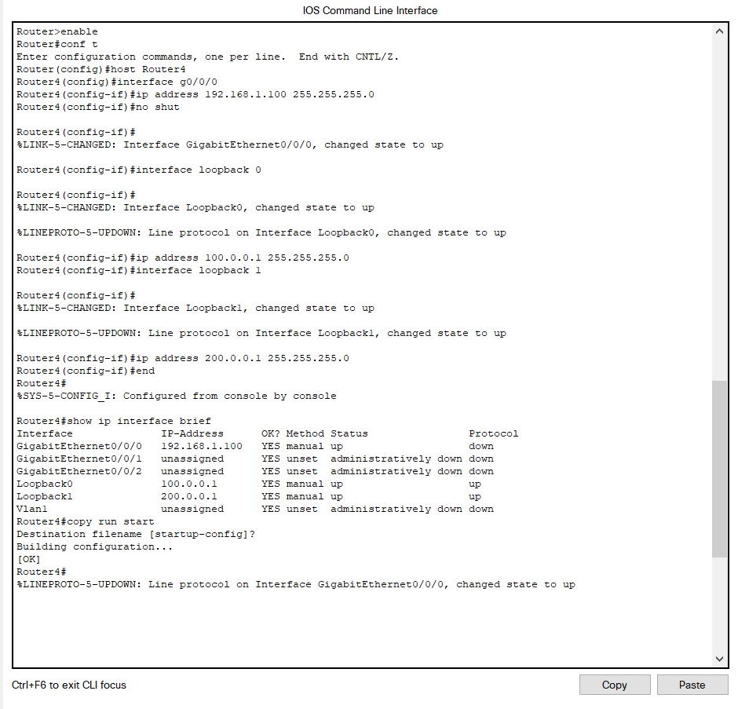
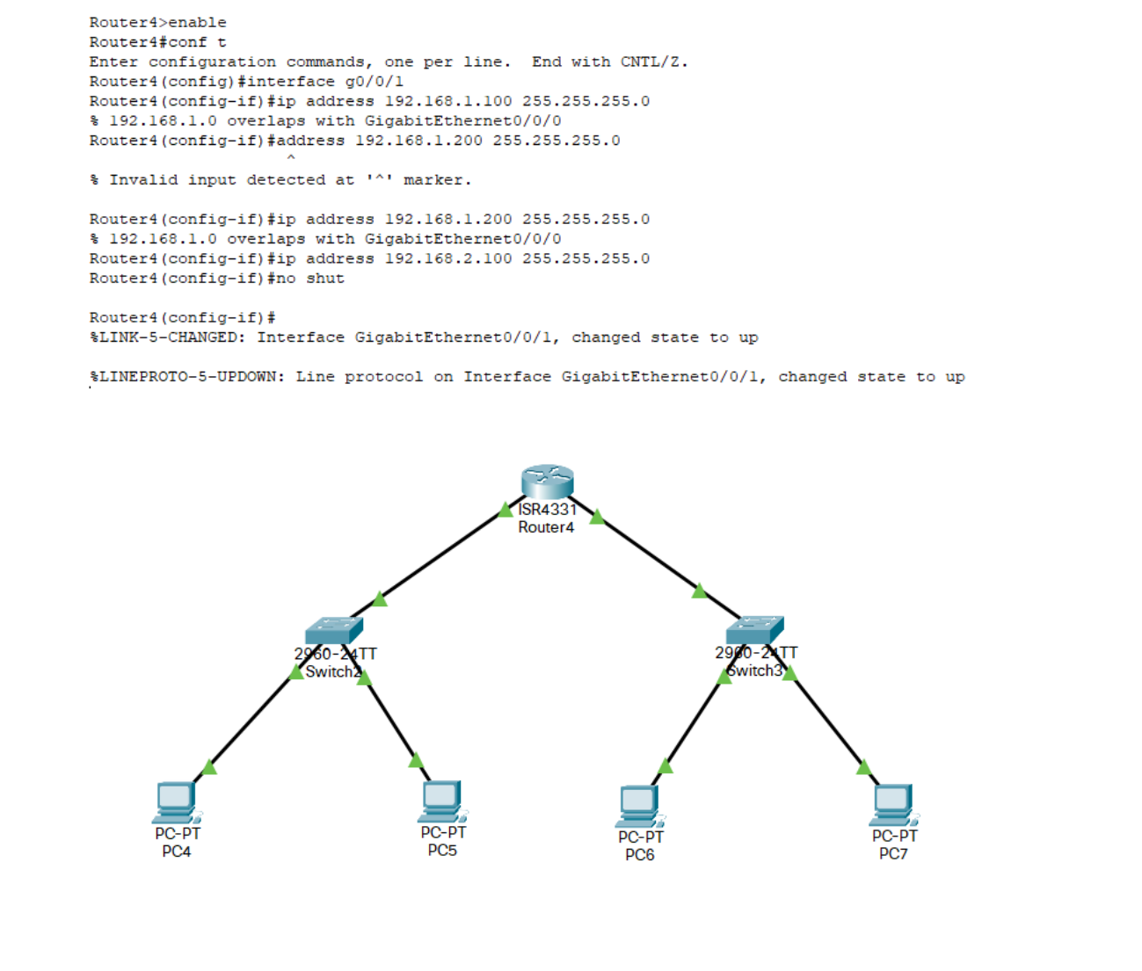

RESULT: The Router was successfully configured.
Experiment 5

AIM: VLAN configuration.

TOOL USED: Cisco Packet Tracer 7.3.1

THEORY: A Virtual LAN (or VLAN) is a domain that is partitioned and isolated in a computer network at the data link layer. Although physically, the terminals are connected to the same switch, logically they are separated and no communication is possible between them unless provisions are made.

Commands:

- enable: To enter privileged EXEC mode, enter the enable command. Privileged EXEC from user EXEC mode, enter the enable command.

- conf t: After you enter the conf t (configure terminal command), the system prompt changes from switch# to switch(config)#, indicating that the switch is in configuration mode.

- vlan: To enable switch VLAN configuration.

- name: To name VLAN on a switch.

- interface: Used for switch interface configuration.

- switchport mode: Used to set the interface type in interface configuration mode.

- switchport access vlan: Used to set the VLAN when the interface is in access mode.
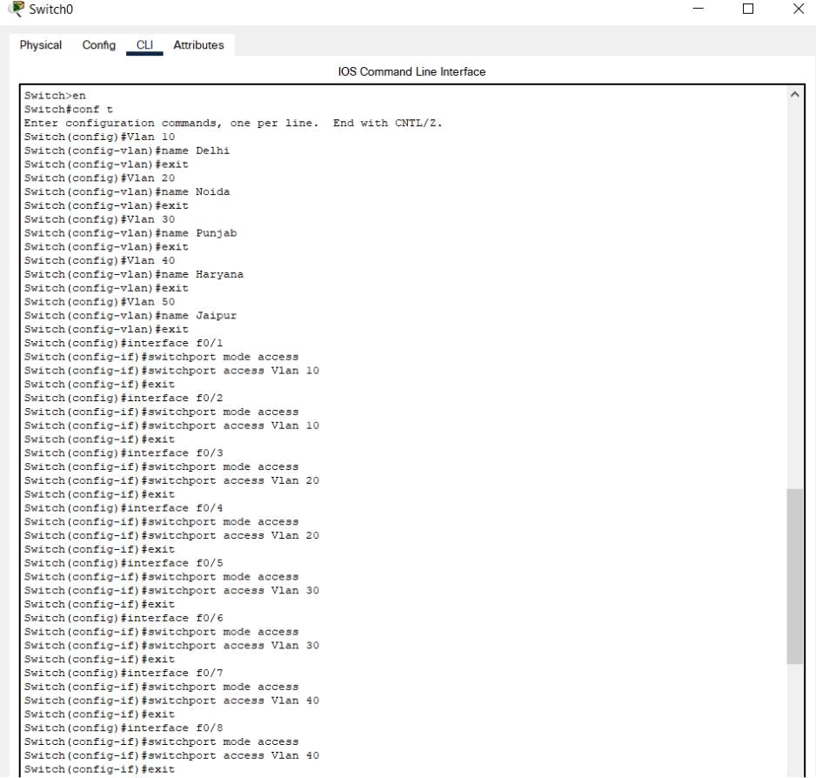
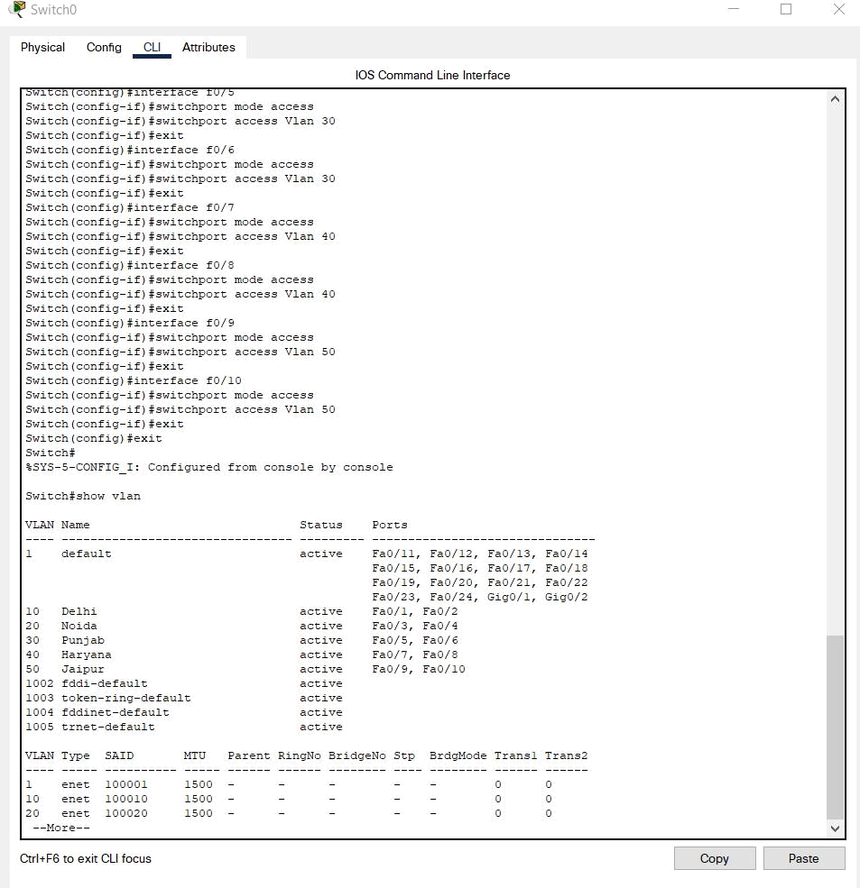

OUTPUT:
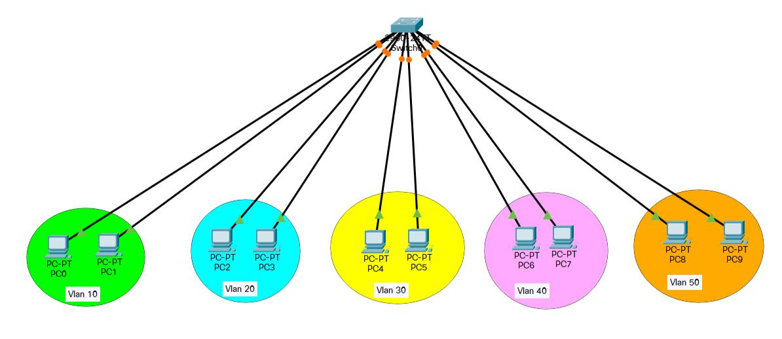

RESULT: The network satisfying requirements was made.
Experiment 6

AIM: DHCP Configuration

SOFTWARE USED: Cisco Packet Tracer

THEORY: Dynamic Host Configuration Protocol (DHCP) is a network management protocol used to automate the process of configuring devices on IP networks, thus allowing them to use network services such as DNS, NTP, and any communication protocol based on UDP or TCP. A DHCP server dynamically assigns an IP address and other network configuration parameters to each device on a network so they can communicate with other IP networks.

OUTPUT:
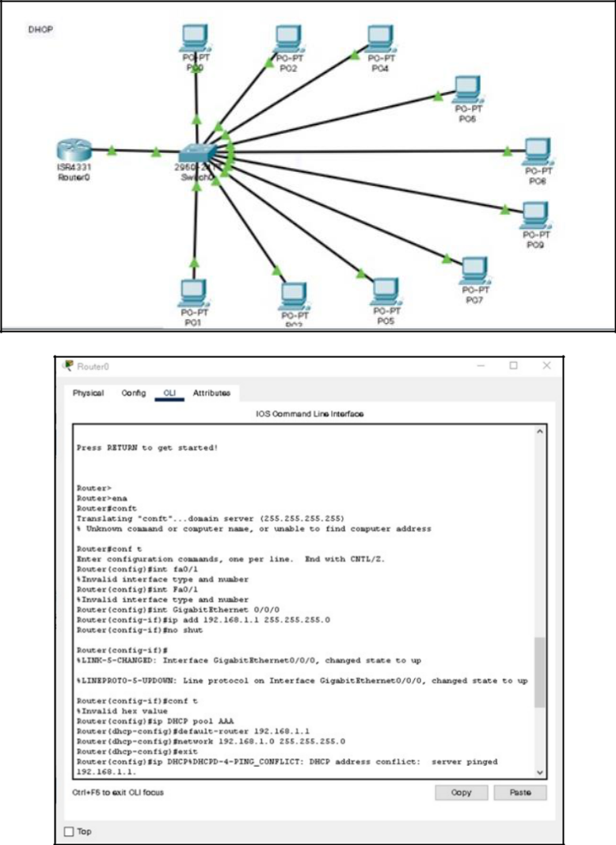

RESULT: DHCP was configured.

Experiment 7

Aim: Wireless router configuration.

Tool used: Cisco Packet Tracer.

Theory: Wireless network configuration encompasses several potential variances across environments. Even in a complex single site, the network configuration basics required for a successful implementation can vary from one wireless network to another running on the same hardware as part of the overall wireless LAN environment.

Commands:

Router> enable

Router# conf t

Router(config)# host Router1

Router1(config)# interface g0/0/0

Router1(config-if)# ip address 192.168.1.100 255.255.255.0

Router1(config-if)# no shut

Router1(config-if)# interface g0/0/1

Router1(config-if)# ip address 192.168.2.100 255.255.255.0

Router1(config-if)# no shut

Router1(config-if)# interface loopback 0

Router1(config-if)# ip address 100.0.0.1 255.255.255.0

Router1(config-if)# interface loopback 1

Router1(config-if)# ip address 200.0.0.1 255.255.255.0

Router1(config-if)# end

Router1# show ip interface brief

Router1# copy run start

OUTPUT:
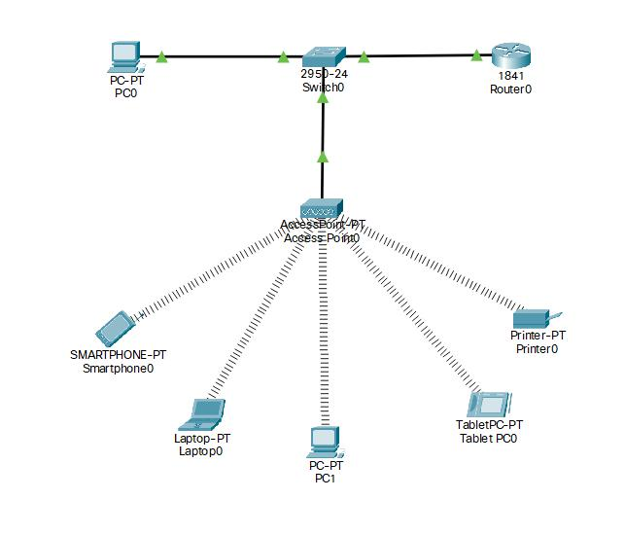
Experiment 8

Aim: RIP configuration.

Tool used: Cisco Packet Tracer.

Theory: RIP stands for Routing Information Protocol. RIP is an intra-domain routing protocol used within an autonomous system. Here, intra-domain means routing the packets in a defined domain, for example, web browsing within an institutional area.

OUTPUT:
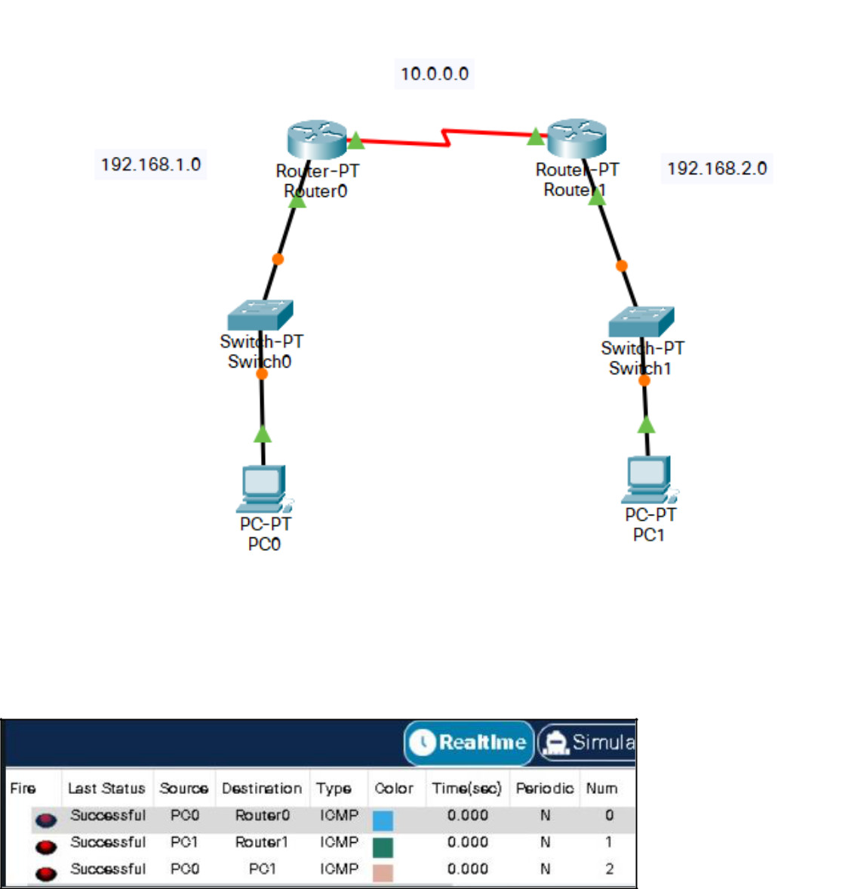

RESULT: RIP was successfully configured.
Experiment 9

Aim: IPv4 configuration.

Tool used: Cisco Packet Tracer.

Theory: IPv4 uses a 32-bit address scheme allowing a total of 2 to the power of 32 addresses or just over 4 billion addresses.[2] This is based on the best-effort model. The model makes sure that there is the avoidance of duplicate delivery. All these aspects are handled by the upper layer of transport.

IPv4 functions on the network layer of the TCP or IP protocol stack. Its main task is mainly to transfer the data blocks from the sending host to the destination host, where the senders and the receivers are computers that are uniquely identified by the Internet Protocol addresses

OUTPUT:
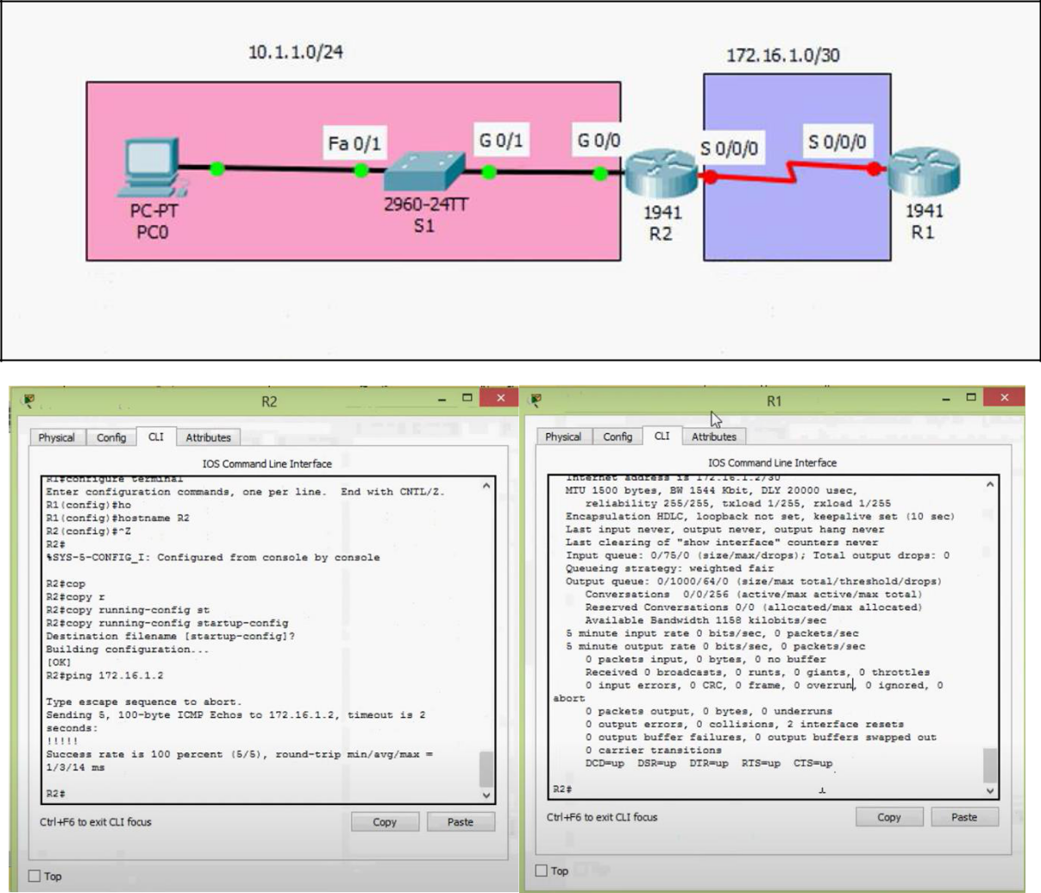

Result: IPv4 was configured.

Experiment 10

Aim: IPv4 subnetting.

Tool used: Cisco Packet Tracer.

Theory: Subnetting is the process of taking a network and splitting it into smaller networks, known as subnets.

It's used to free up more public IPv4 addresses and segment networks for security and easier management. A subnet defines the number of bits, out of 32, used for the "network portion" of the address. Subnet masks can also be defined in a more common 'slash' representation, known as CIDR notation.

OUTPUT:
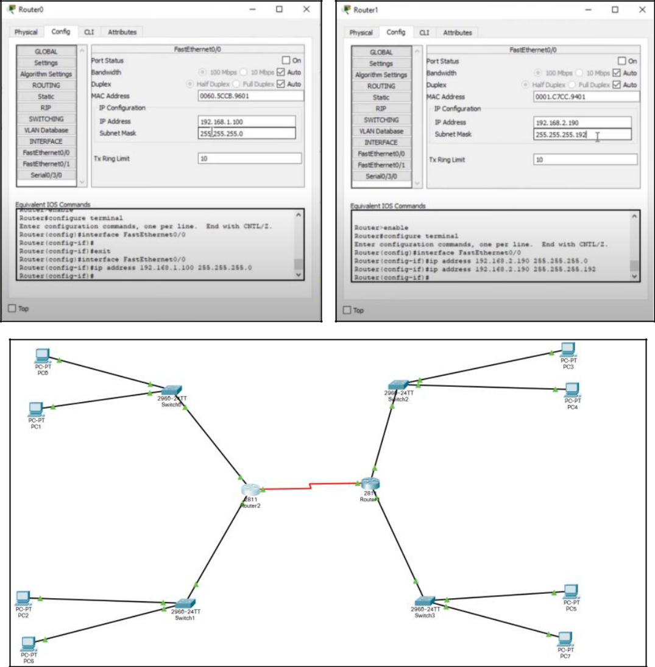

RESULT: IPv4 Subnetting performed successfully.

